NAME: LINDOKUHLE
SURNAME: GABUZA
GROUP: 4
STUDENT NUMBER: ST10536739
MODULE NAME: WEB DEVELOPMENT
MODULE CODE: WEDE5020

PROJECT PROPOSAL 1

Table of Contents
1. Organization overview 3
2.WEBSITE GOALS AND OBJECTIVES 3
3.CURRENT WEBSITE ANALYSIS 4
4.PROPOSED WEBSITE FEATURES AND FUNCTIONALITY 5
5.DESIGN AND USER EXPERIENCE 6
6.TECHNICAL REQUIREMENTS 7
7.TIMELINE AND MILESTONES 7
8.BUDGET 8
9.REFERENCES 8

Organization overview
- Name of organization: Voltage wear
Voltage wear is a fictional fast-fashion retail brand inspired by the global success of the Zara brand. Founded in 2020. Voltage wear started as a small boutique; the brand has grown into a well-recognized name in the fashion industry in South Africa. The brand is known for its ability to create clothes that represent all the South African cultures with modern clothes.
- MISSION STATEMENT
“To give customers affordable fashion that empowers individuals to express their personal style with confidence.”
- VISSION STATEMENT
“To become the leading affordable fashion brand known for sustainability, inclusivity, and style innovation.”
- TARGET MARKET
Individuals aged between 18 and 35 years, but the brand also serves teenagers and professionals in their mid-40s with specific lines and design. They consistently offer trendy collections for both men and women, making sure that their product range is diverse enough to cater to the taste of both genders.

2.WEBSITE GOALS AND OBJECTIVES

- The websites’ goals and objectives

- Increase online brand visibility and attract new customers
- Provide an easy to navigate online catalogue of products
- Build customer loyalty through a professional, engaging web presence
- Generate online sales and in-store foot traffic

- Key performance indicators (KPIs)

- Monthly Website Visitors: Get 5,000+ visitors within 3 months of launch.
- Bounce Rate: Have below 45%.
- Product Enquiries via Form: Get 50+ enquiries per month
- Page Load Speed: Under 3 seconds on desktop and mobile

3.CURRENT WEBSITE ANALYSIS

As Voltage Wear is a fictional organisation, the is no existing website currently. The proposed website will be built from scratch. The absence of an existing online presence represents a significant gap in the brands digital strategy, and this project aims to address that directly.

4.PROPOSED WEBSITE FEATURES AND FUNCTIONALITY

ESSENTIAL FEATURES
- HOMEPAGE: Navigation menu, Trending collection, “New in” selection
- Enquiry Page: Product or service enquiry form with JavaScript validation
- PRODUCT DETAIL PAGE: Categorized product listings, Size guide, Real-time stock availability per size, Save to Wishlist
- ABOUT US PAGE: Brand history, mission and vision, and team overview
- CONTACT PAGE: Contact form, store locations, and business hours

DESIRED FUNCTIONALITY
PERSONALIZATION
- “Recommended for you” based on browsing and purchasing history
SEARCH
- When searching for an item also show similar items

5.DESIGN AND USER EXPERIENCE

COLOUR SCHEME
- White and black
TYPOGRAPY
- Display headings should be elegant
- Body text is Lato
LAYOUT AND DESIGN APPROACH
- Sticky navigation bar so it is always accessible
- No pop-up banners interrupting the browsing experience
  - USER EXPERIENCE CONSIDERATIONS
NAVIGATION
- Categories with trending, and new arrivals visible at glance
- Search bar expands into a full overlay with instant result
LAYOUT
- Smooth page transition
COLOUR SCHEME
- Colour-coded tags: “New in” in black,” Sale” in burgundy
- Use grey for out-of-stock items

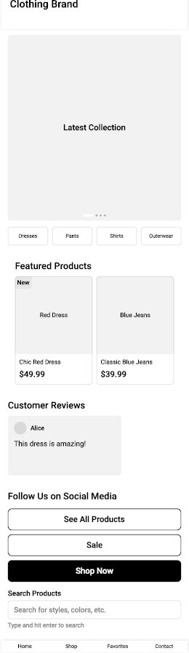

6.TECHNICAL REQUIREMENTS

PROGRAMING LANGUAGES AND FRAMEWORK
- HTML, CSS, JavaScript for web structure and styling
- React.js for building interactive user interface
- Next.js for fast page loading
- PostgreSQL is for the database for products, orders, and user data
- Figma for design and wireframing
- GitHub for version control

7.TIMELINE AND MILESTONES

PART ONE
- WEEK 1: Research, planning, and finalising proposal
- WEEK 2-3: Contant research and sourcing, Website structure and planning
- WEEK 4-5: Testing and debugging
PART TWO
- WEEK 1-2: Working through feedback from part one and CSS styling for desktop
- WEEK 3-4: Responsive design
PART THREE
- WEEK 1-2: Working trough feedback from part 2 and functionality
- WEEK 3-5: Search engine optimization and forming functionality and validation

8.BUDGET

- DOMAIN NAME (.CO .ZA/.COM): R100 – R300/year
- Web Hosting: R800 – R2,500/year
- Website Maintenance & support: R500 - R2,000/month
- SSL Certificate: Often included in hosting
- SEO/Marketing Services: R1,000 – R5,000+/month
Estimated total (one-time development cost): R12,000 – R30,000+
Estimated Monthly Running Costs: R7,000+

9.REFERENCES
Ravens dale – www.ravendale.co.za (Website Prices)

